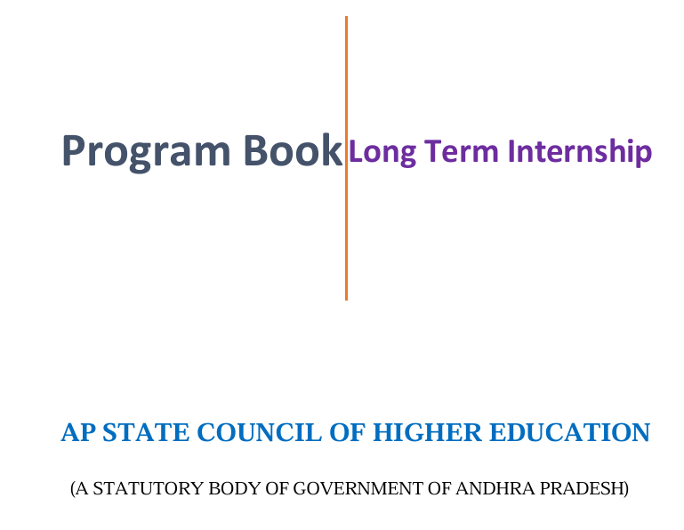

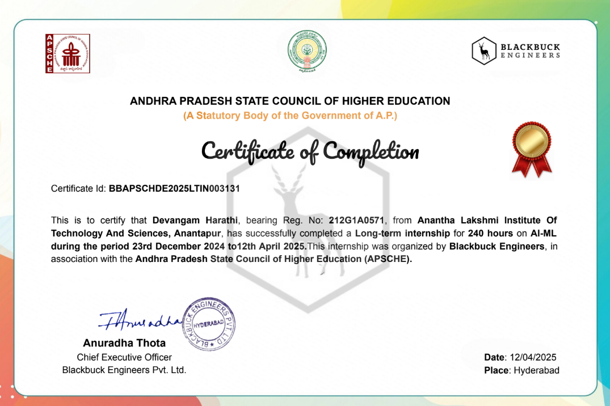

**AI-ML**

**A Long-Term Internship Project Report**

**Submitted in partial fulfillment of the requirements for the award of the degree of**

**BACHELOR OF TECHNOLOGY**

**in**

**COMPUTER SCIENCE AND ENGINEERING**

**by**

**DEVANGAM HARATHI**

**(212G1A0571)**

**Under the Esteemed Guidance of**

**Dr. K. BHARGAVI M. Tech., Ph.D.**

**Associate Professor & HOD,** **Department of Computer Science and Engineering**



**DEPARTMENT OF COMPUTER SCIENCE AND ENGINEERING ANANTHA LAKSHMI INSTITUTE OF TECHNOLOGY & SCIENCES**

**Approved by AICTE,NEW DELHI & Affiliated to J.N.T.U. Anantapur, Accredited by NACC Itukalapalli(v), Near S.K. University Anantapur – 515721 Andhra Pradesh.**

**2024-2025**

**ANANTHA LAKSHMI INSTITUTE OF TECHNOLOGY & SCIENCES**

**Approved by AICTE, NEW DELHI & Affiliated to J.N.T.U. Anantapur, Accredited by NACC Itukalapalli(v), Near S.K. University Anantapur – 515721 Andhra Pradesh**

**DEPARTMENT OF COMPUTER SCIENCE AND ENGINEERING**



**CERTIFICATE**

This is to certify that the **LONG** - **TERM INTERNSHIP** entitled **AI-ML** being submitted by **DEVANGAM HARATHI** bearing reg.no.**212G1A0571,** at **BLACKBUCK ENGINEERS PRIVATE LIMITED** during academic year 2024 – 2025, in partial fulfillment of the requirements for the award of degree of **BACHELOR OF TECHNOLOGY** in **COMPUTER SCIENCE AND ENGINEERING** and work was carried out by her under my guidance and supervision. The result provided in this report has not been submitted to any other university or institution for the award of any degree.

|  |  |
| --- | --- |
| **Signature of the Supervisor**  **Dr. K. Bhargavi M.Tech, Ph. D**  Associate Professor & HOD,  Department of Computer Science and Engineering,  Anantha Lakshmi Institute of  Technology and Sciences ,Anantapur | **Signature of the HOD**  **Dr. K. Bhargavi M.Tech, Ph. D**  Associate Professor & HOD, Department of Computer Science and Engineering,  Anantha Lakshmi Institute of  Technology and Sciences ,Anantapur. |

**PROGRAM BOOK**

**FOR**

**LONG-TERM INTERNSHIP**

**Name of the Student :** Devangam Harathi

**Name of the College :** Anantha Lakshmi Institute of Technology and

Sciences

**Registration Number :** 212G1A0571

**Period of Internship : From**: 23/12/2024 **To**: 12/04/2025

#### Name & Address

**Of the Intern Organization :** Blackbuck Engineers Private Limited ,Hyderabad, Telangana.

# An Internship Report

**On**

**AI-ML**

**Submitted in accordance with the requirement for the degree of**

**BACHELOR OF TECHNOLOGY**

## IN

**COMPUTER SCIENCE AND ENGINEERING**



**Name of the College :**Anantha Lakshmi Institute of Technology and

#### Sciences

**Department :**Computer Science and Engineering

**Name of the Faculty Guide :** Dr. K. Bhargavi M.Tech, Ph. D

**Duration of the Internship : From:** 23-12-2024 **To:**12-04-2025 **Name of the Student :** Devangam Harathi

**Programme of Study :** Bachelor of Technology

**Year of Study :** 2021-2025

**Register Number :** 212G1A0571

**Date of Submission :** 15/04/2025

# STUDENT DECLARATION

I **DEVANGAM HARATHI**, a student of Long-term **Internship Program, Reg. No. 212G1A0571**, from the **Department of Computer Science and Engineering, Anantha Lakshmi Institute of Technology and Sciences**, do hereby declare that I have successfully completed the **mandatory internship** from 23-12-2024 to 12-04-2025 **at BLACKBUCK ENGINEERS PRIVATE LIMITED** under the faculty guidance of **Dr. K. Bhargavi M.Tech, Ph. D** Associate Professor & HOD, Department of **Computer Science and Engineering, Anantha Lakshmi Institute of Technology and Sciences.**

**(Signature and Date)**

#### Endorsements

Faculty Guide

Head of the Department

Principal

# CERTIFICATE FROM INTERN ORGANIZATION

This is to certify that **Devangam Harathi**, Reg. No. **212G1A0571**, of **Anantha Lakshmi Institute of Technology and Sciences**, has successfully undergone an internship **at Blackbuck Engineers Private Limited** from 23-12-2024 to12-04-2025.

The overall performance of the intern during her internship is found to be Satisfactory.



Authorized Signatory with Date and Seal

# ACKNOWLEDGEMENTS

Firstly, I extend my heartfelt thanks to the, Blackbuck Engineers Private Limited, and the Andhra Pradesh State Council of Higher Education (APSCHE) for providing me with the opportunity to be part of such a valuable learning experience. Your support and resources have been instrumental in my professional growth.

I extend my heartfelt thanks to the **Ms. Anuradha Thota,** **CEO** of **Blackbuck Engineers Private Limited**, and Andhra **Pradesh State Council of Higher Education (APSCHE)** for providing me with the opportunity to be part of such a valuable learning experience. Your support and resources have been instrumental in my professional growth.

I am especially grateful to my mentor and guide **Dr. K. BHARGAVI M. Tech, Ph.D., Associate Professor & HOD,** **Department of Computer science and Engineering in ALTS,** whose guidance, feedback, and encouragement were crucial in helping me navigate through various challenges and achieve my learning objectives. Your expertise and willingness to share knowledge greatly contributed to my development

I wish to convey our special thanks to **DR. B.M.G. PRASAD M. Tech, Ph.D.,** **DEAN of CSE DEPARTMENT**, **Anantha Lakshmi Institute of Technology and Sciences,** for giving the required information in doing my project work.

I wish to convey my special thanks **to Dr. RAMAMURTHY M.Tech.,Ph.D.,** **Principal of Anantha Lakshmi Institute of Technology and Sciences** for giving the required information in doing my project work. Not to forget, we thank all other faculty and non teaching staff, and my friends who had directly or indirectly helped and supported us in completing my project in time.

We also express our sincere thanks to **Sri M. ANANTHA RAMUDU**, Chairman and **Sri M. RAMESH NAIDU,** **Vice Chairman** of **Anantha Lakshmi Institute of Technology and Sciences** for providing excellent facilities.

Lastly, I would like to acknowledge the support of my family and friends, who encouraged me through out this journey.Your understanding and encouragement have been a source of strength and motivation. Thank you all for your invaluable support and contribution.

With Gratitude,

Devangam Harathi

212G1A0571

**INTERNSHIP CERTIFICATE**



**CHAPTER 1 : EXECUTIVE SUMMARY**

This report provides a concise overview of my internship experience with a focus on Artificial Intelligence and Machine Learning (AIML). It outlines the learning objectives, outcomes achieved, the sector and organization involved, and the key activities undertaken during the internship period.

**1.1 Learning Objectives and Outcomes Achieved**

**1.1.1 Objectives:**

a) Understand the fundamentals of machine learning, including supervised, unsupervised, and reinforcement learning techniques.  
b) Develop proficiency in AI/ML tools and libraries such as Python, Scikit-learn, Tensor Flow, and Jupyter Notebooks.  
c) Gain hands-on experience in building, training, and evaluating machine learning models.  
d) Learn data preprocessing techniques and feature engineering to improve model performance.  
e) Collaborate effectively within cross-functional teams and participate in agile-based research and development workflows.

**1**.**1.2. Outcomes:**

a) Built and evaluated various machine learning models for classification and regression problems.  
b) Worked on real-world datasets, applying data cleaning, normalization, and feature extraction techniques.  
c) Gained hands-on experience with libraries like Scikit-learn and TensorFlow to implement AI solutions.  
d) Learned model evaluation metrics such as accuracy, precision, recall, and F1 score.  
e) Collaborated on group projects involving problem-solving, version control (Git), and agile sprint activities.

**1.2. Sector of Business and Intern Organization**

The internship took place in the technology sector, specifically focusing on Artificial Intelligence and Machine Learning. The organization I interned with—Blackbucks Engineers Private Limited—is a reputable software and AI development firm that collaborates with academic and industrial partners to build innovative AI-driven applications. The organization caters to a wide range of domains, including education, finance, healthcare, and e-governance.

**1.3. Summary of Internship Activities:**

a) Conducted exploratory data analysis (EDA) on structured datasets using Pandas and Matplotlib.  
b) Applied supervised learning algorithms such as logistic regression, decision trees, and SVM for predictive modeling.  
c) Utilized unsupervised techniques like K-means clustering for data segmentation.  
d) Participated in regular code reviews, collaborative coding sessions, and academic discussions on current AI research trends.

**CHAPTER 2: OVERVIEW OF THE ORGANIZATION**

**2.1. Introduction of the Organization**

Blackbucks Engineers Private Limited is an emerging leader in AI-driven software solutions, focused on delivering intelligent applications across domains such as education, finance, and public governance. Partnering with APSCHE and Blackbuck Engineers Private Limited , the organization provides hands-on learning experiences for students pursuing careers in cutting-edge technologies like Artificial Intelligence and Machine Learning (AI/ML).

**2.2.Vision, Mission, and Values of the Organization**

**Vision:** To revolutionize the global digital landscape through advanced AI and automation technologies.  
**Mission:** To bridge the gap between academic learning and industry demands by enabling real-time AI-based innovations through research, skill development, and collaborative project execution.  
**Core Values:**

* **Innovation:** Encouraging continuous technological advancements
* **Integrity:** Maintaining ethical practices in data and AI usage
* **Excellence:** Delivering high-performance AI solutions
* **Collaboration:** Promoting teamwork between academia and industry
* **Empowerment:** Skilling the next generation of AI professionals

**2.3. Policy of the Organization, in Relation with the Intern Role**

The internship program is structured to provide meaningful, supervised, and time-bound exposure to real-world AI and ML projects. Interns receive access to datasets, industry-grade tools, and project mentorship. They are treated as junior contributors, working on modules related to machine learning pipelines, data processing, and model integration. The organization ensures that internships are beneficial to both students and the firm through hands-on learning and performance-based assessments.

**2.4.Organizational Structure**

Blackbucks Engineers maintains a dynamic and collaborative structure. The AI and ML division includes:

* **AI Researchers** who focus on innovation and experimentation
* **Data Scientists** responsible for modeling and analytics
* **Software Developers** for integrating AI with scalable systems
* **Interns** who assist in data preparation, modeling, and performance tuning  
  Each project team is led by a mentor and supported by project coordinators who bridge academic institutions and internal development units.

**2.5. Roles and Responsibilities of the Employees in which the Intern is Placed**

As an AI/ML intern, I was part of a collaborative team where my primary responsibilities included:

* Cleaning and preprocessing structured datasets using Pandas and NumPy
* Building and validating machine learning models (classification, regression, clustering)
* Working with Python libraries like Scikit-learn and Tensor Flow
* Contributing to Jupyter Notebook-based research documentation
* Participating in agile sprints, reviews, and knowledge-sharing sessions

**2.6. Performance of the Organization in Terms of Turnover, Profits, Market Reach, and Market Value**

Blackbucks has reported increasing demand for its AI consulting and product development services. It has successfully delivered AI solutions in sectors like smart education (adaptive learning tools), public services (predictive analytics), and finance (fraud detection models). The organization’s academic partnerships have also strengthened its market visibility and credibility, positioning it as a trusted AI training and implementation partner.

**2.7. Future Plans of the Organization**

Looking ahead, Blackbucks aims to:

* Launch its proprietary AI platforms in education and healthcare
* Expand research initiatives through collaboration with global universities
* Establish dedicated AI labs for experimentation with NLP, computer vision, and reinforcement learning
* Incorporate cloud-based deployment and edge computing into its AI delivery model
* Train and certify over 25,000 students through its advanced AI/ML internship programs

**CHAPTER 3: INTERNSHIP PART**

During my internship provided an in-depth learning experience in Artificial Intelligence & Machine Learning, covering fundamental concepts, programming skills, advanced AI/ML techniques,andreal-worldapplications.Throughstructuredweeklysessions,students enhanced their analytical, programming, and problem-solving skills, making them industry-ready for AI-driven careers.

**3.1. Activities/Responsibilities:**

a) Understanding and exploring fundamental AI/ML concepts and algorithms.  
b) Performing data preprocessing and exploratory data analysis using Python.  
c) Implementing supervised learning algorithms like linear regression and decision trees.  
d) Applying unsupervised learning techniques including clustering and dimensionality reduction.  
e) Building and training neural networks for classification tasks.  
f) Optimizing model performance through hyperparameter tuning and regularization.  
g) Deploying machine learning models using Flask/Django frameworks.  
h) Collaborating with mentors and peers to review code and discuss algorithm efficiency.  
i) Presenting weekly progress reports and completing a final capstone project.

**3.2. Working Conditions:**

The working conditions during the internship were conducive to learning and collaboration. I worked in a virtual/hybrid environment, equipped with required resources including access to datasets, online tools, and mentor guidance. Communication with peers and instructors occurred through regular video conferencing and collaboration platforms, fostering a supportive learning atmosphere.

**3.3. Weekly Work Schedule (Example):**

**Week 1:**

* Orientation and introduction to the company’s development processes, tools, and methodologies.

Familiarization with the existing projects, technologies, and frameworks used in AI & ML development..

### Weeks 2 - 12:

* Mastered Python programming concepts including functions, data structures, and control flow.
* Developed expertise in building Machine Learning models using both supervised and unsupervised learning techniques.
* Gained proficiency in essential Python libraries for AI/ML such as NumPy, Pandas, Matplotlib, TensorFlow, and Scikit-learn.
* Learned and applied data preprocessing techniques including data cleaning, transformation, and feature engineering.
* Explored optimization techniques to enhance model accuracy, performance, and efficiency.
* Understood real-world AI applications and implemented them through hands-on projects.
* Gained practical experience in executing projects end-to-end, from data preprocessing to model deployment.
* Improved debugging skills, model testing, and performance tuning for better results.
* Developed the ability to analyze business problems and propose AI-driven solutions.
* Strengthened analytical thinking, problem-solving, and decision-making skills relevant to AI/ML roles.
* Enhanced communication, teamwork, collaboration, and project management abilities through group activities.
* Understood current job market trends and emerging career opportunities in AI and ML fields.
* Gained experience in working on industry-relevant projects and presenting findings effectively.

### Week 13:

* Built confidence in handling real-world Machine Learning challenges and crafting suitable solutions.
* Final presentation and review of the work completed during the internship, demonstrating learning outcomes, project results, and acquired skills.

**3.4. Equipment Used:**

* High-performance desktop/laptop computers with GPU support.
* Python IDEs such as Jupyter Notebooks, PyCharm, and VS Code.
* Machine learning libraries: Scikit-learn, TensorFlow, Keras, Pandas, NumPy.
* Data visualization tools: Matplotlib, Seaborn.
* Git for version control and project collaboration.

**3.5-Reflection on Acquired Skills:**

Throughout this internship, I developed a strong foundation in both the theoretical and practical aspects of machine learning. I became proficient in Python and various AI/ML libraries, mastered the process of preparing and analyzing data, and successfully implemented and evaluated ML models. I also gained experience in deploying models in production-like environments and working in a collaborative, agile setting. This experience significantly enhanced my capabilities as an aspiring AIML professional and prepared me for real-world roles in intelligent system development.

**WEEKLY REPORT**

**WEEK - 1(From Dt 06-01-25 To Dt 11-01-25)**

**Objective of the Activity Done:** To understand the structure and expectations of placement assessments and prepare for AI/ML-based recruitment processes.

**Detailed report:**

**1. Overview of the Activities**

During this week, we focused on understanding the placement process, particularly from the perspective of AI/ML job roles. We were guided to recognize our technical strengths and weaknesses. Sessions helped us understand the common patterns followed in placement assessments and the importance of structured problem-solving. We also became familiar with the types of questions generally asked in aptitude and technical rounds.

Two main assessments were conducted:

* **Placement Test 01**:  
  This test evaluated our aptitude, logical reasoning, and programming skills. It helped in identifying knowledge gaps and introduced various problem-solving strategies relevant to AI/ML recruitment exams.
* **Employability Test 01**:  
  This test focused on communication, analytical, and technical skills. We received insights into industry expectations and how to prepare effectively for technical interviews and soft skill evaluations.

**2. Outcomes and Learnings**

* Developed a comprehensive understanding of AI/ML-specific placement processes and assessment strategies to enhance performance.
* Recognized the importance of combining strong technical expertise with effective communication and soft skills for interview success**.**

**WEEKLY REPORT**

**WEEK - 2(From Dt 13-01-25 To Dt 18-01-25)**

**Objective of the Activity Done:** Strengthening Aptitude and Employability Skills for AI/ML Job Readiness

**Detailed Report:**

In the second week of the internship program, the focus was on enhancing aptitude and employability skills that are essential for success in the field of Artificial Intelligence and Machine Learning (AI/ML). The training sessions emphasized logical reasoning, critical thinking, and the development of soft skills required to excel in technical roles.

The Placement Test provided hands-on experience in solving aptitude and technical questions under time constraints. It introduced case-study-based questions simulating real-world AI problem-solving scenarios. The test helped improve logical reasoning skills and exposed us to different types of assessments frequently encountered in AI/ML recruitment processes.

The Employability Test was aimed at evaluating and improving key soft skills such as teamwork, adaptability, and communication. It also assessed our presentation skills and our ability to clearly explain AI/ML concepts to a broader audience. The session emphasized the importance of professional ethics and workplace communication, aligning us with the expectations of the corporate world.

This week significantly contributed to building both technical and interpersonal skills, making us more confident and job-ready for AI/ML roles in the industry.

**WEEKLY REPORT**

**WEEK - 3(From Dt 20-01-2025 To Dt 25-01-2025)**

**Objective of the Activity Done**: To understand the foundational concepts of Artificial Intelligence and Machine Learning, including their real-world applications, learning types, and career opportunities.

**Detailed Report**:

This week marked the beginning of in-depth learning in the domain of Artificial Intelligence and Machine Learning. The sessions provided a strong conceptual overview of AI, ML, and Deep Learning, highlighting their definitions, inter-relationships, and importance in modern-day technology. We explored various real-world applications across domains such as healthcare, finance, retail, and automation, helping us understand how AI is being integrated into our daily lives. In particular, case studies were shared to demonstrate how AI-powered automation is revolutionizing businesses and improving operational efficiency.

The fundamentals of Machine Learning were introduced by categorizing learning techniques into three primary types: Supervised Learning, which involves classification and regression using labeled data; Unsupervised Learning, which helps identify patterns through clustering and association; and Semi-Supervised Learning, which utilizes both labeled and unlabeled data to enhance model performance. This classification helped in distinguishing the different types of problems ML can solve.

We also learned about the Machine Learning Life Cycle, which includes stages such as data collection, preprocessing, model building, training, evaluation, deployment, and optimization. Common algorithms and real-time applications were discussed to enhance practical understanding. Additionally, placement and employability tests during the week focused on evaluating AI-related problem-solving abilities, introducing debugging techniques, and providing feedback on teamwork, communication, and AI/ML soft skills.

**WEEKLY REPORT**

**WEEK - 4(From Dt 27-01-2025 To Dt 01-02-2025)**

**Objective of the Activity Done**: To strengthen understanding of core Python and AIML concepts through practice assessments and deepen knowledge of machine learning fundamentals and applications.

**Detailed Report**:

This week focused on strengthening Python programming and applying core AI/ML concepts through targeted assessments and guided sessions. It began with a practice test that served as a diagnostic tool to evaluate our understanding of logical reasoning, coding, and AIML basics. An AIML assessment was conducted, covering foundational topics such as data preprocessing, basic machine learning algorithms, and Python logic. The assessment, which included both theoretical and coding-based questions, helped sharpen our problem-solving skills in real-time scenarios.

We were introduced to TaPTaP, a platform designed to track skill development and placement readiness. This was followed by a placement test that tested a combination of technical and aptitude skills including logical reasoning, quantitative ability, verbal skills, and hands-on coding—crucial for AI/ML-focused placements. These evaluations helped us identify personal areas for improvement while boosting confidence in the areas we excelled.

In the latter part of the week, a comprehensive session delved into Machine Learning concepts, including its history, applications, and learning paradigms such as Supervised, Unsupervised, and Semi-Supervised learning, while discussing key algorithms like classification, regression, and clustering through real-world use cases. The week culminated with another AIML assessment and an employability test, which collectively evaluated feature engineering, model optimization, and placement readiness—thereby strengthening foundational knowledge essential for aspiring professionals in the AIML domain.

**WEEKLY REPORT**

**WEEK - 5(From Dt 03-02-2025 To Dt 08-02-2025)**

**Objective of the Activity Done**: To build mastery over Python flow control structures, loop handling, and string manipulation techniques, reinforcing foundational programming logic through assessments and real-time examples.

**Detailed Report**:

This week’s sessions focused on strengthening foundational Python programming skills, with emphasis on control structures, operators, conditional logic, and string methods. The week began with a session on Python basics, covering variables, data types, and operators including arithmetic, comparison, logical, bitwise, membership, and identity. Conditional statements such as if, if-else, and if-elif-else were introduced using practical examples to demonstrate real-world decision-making logic in Python programs.

Assessment and placement tests were conducted to evaluate our grasp of Python fundamentals, logical reasoning, and technical aptitude. These assessments featured a mix of multiple-choice questions and coding tasks, reinforcing our ability to apply core programming concepts in practical scenarios. We explored Python loops (while and for), loop control statements (break, continue, pass), and nested conditions for complex logic building. Additionally, we learned key string methods like len(), lower(), upper(), strip(), split(), and replace(), along with string formatting using f-strings and .format().

The learning continued with another assessment that tested our understanding of loop structures, string manipulation, and nested logic. We then advanced to more refined flow control techniques, focusing on the strategic use of break and continue for optimizing loop behavior. Sessions also covered string comparison methods such as ==, !=, <, >, startswith(), and endswith(), alongside case-insensitive comparisons using .lower(). Sorting and searching techniques within strings were practiced to strengthen our ability to process and analyze textual data efficiently.

**WEEKLY REPORT**

**WEEK - 6(From Dt 10-02-2025 To Dt 15-02-2025)**

**Objective of the Activity Done**: To develop a strong understanding of functions in Python, both built-in and user-defined, and apply them to solve computational tasks efficiently. To explore array processing using NumPy for mathematical and statistical operations, including array manipulation, slicing, and solving problems like the Two Sum Array challenge.

**Detailed Report**:

In Week 06, we strengthened our Python skills by exploring functions in depth. We learned to use built-in functions like print(), len(), sum(), and max(), and created user-defined functions using the def keyword. The session also introduced lambda functions for writing concise, anonymous functions. We explored different types of arguments—**positional, keyword, default, *args, and **kwargs—to make our functions more flexible. To apply these concepts, we developed a simple calculator that used separate functions for each arithmetic operation. Assessments and placement tests during the week tested our grasp on function-based logic and debugging skills.

We were also introduced to NumPy, a powerful Python library for numerical computing. We learned how NumPy arrays offer better performance than regular lists and practiced using functions like np.array(), np.zeros(), np.ones(), np.arange(), and np.linspace(). Key array operations like slicing, reshaping, and element-wise arithmetic were covered. We explored array attributes like .shape and .ndim to better understand multi-dimensional structures.

To reinforce our learning, we solved the Two Sum problem using both brute-force and optimized techniques. We also performed statistical operations such as mean, median, variance, standard deviation, and correlation using NumPy. Another assessment evaluated our knowledge of NumPy, with a focus on array manipulation and mathematical computations in Python.

.

**WEEKLY REPORT**

**WEEK - 7(From Dt 17-02-2025to Dt 22-02-2025)**

**Objective of the Activity Done:** To build foundational skills in handling numerical data using NumPy, focusing on array creation, manipulation, slicing, statistical analysis, and solving real-world problems efficiently.

**Detailed Report:**

This week’s session introduced learners to NumPy, a powerful library for numerical and scientific computing in Python. The session focused on creating arrays using methods like np.array(), np.zeros(), np.ones(), and performing mathematical operations on them. Learners explored key concepts such as array slicing, reshaping, and element-wise operations.

Differences between shape and dimension (.shape vs .ndim) were demonstrated using practical examples. Learners also applied statistical operations like calculating the mean, median, variance, and standard deviation on datasets.

The session concluded with the implementation of the Two Sum Problem, which allowed participants to apply their knowledge to solve a common coding challenge using both brute-force and optimized approaches.

Assessment 07 was conducted to evaluate the learners’ understanding of NumPy concepts, including slicing, reshaping, and statistical computations through hands-on coding tasks.

**WEEKLY REPORT**

**WEEK - 8(From Dt 24-02-2025 To Dt 01-03-2025)**

**Objective of the Activity Done:** To introduce learners to data inspection, visualization techniques using Matplotlib, and data merging strategies using Pandas for effective analysis and interpretation.

**Detailed Report:**

This week’s session introduced learners to essential techniques for exploring, visualizing, and combining data using Python libraries such as Pandas and Matplotlib. The first part of the session focused on loading and inspecting datasets from various file types including CSV, Excel, and JSON. Using Pandas functions like .head(), .info(), .describe(), and .shape(), learners were able to understand the structure and summary of datasets.

The second part of the session covered data visualization using Matplotlib, where participants created line plots, histograms, scatter plots, bar charts, box plots, and pie charts. These visual tools helped in analyzing trends, distributions, and relationships within the data. Learners also practiced enhancing their plots by adding titles, axis labels, legends, and customizing plot styles for better readability.

Finally, the session concluded with data merging techniques using Left Join and Inner Join with the merge() function in Pandas. These techniques are vital for combining multiple datasets efficiently, which is a key step in data preprocessing for machine learning and analytics.

This session strengthened participants’ data handling skills and prepared them for deeper analysis in upcoming topics.

**WEEKLY REPORT**

**WEEK - 9(From Dt 03-03-2025 To Dt 08-03-2025)**

**Objective of the Activity Done:** To introduce learners to fundamental machine learning models using the Scikit-Learn library, including Linear Regression, Logistic Regression, and Decision Trees, with a focus on practical implementation and evaluation.

**Detailed Report:**

This week provided a hands-on introduction to essential machine learning models through the Scikit-Learn library. Participants learned how to import datasets, train predictive models, and evaluate their performance using real-world examples. The session began with Linear Regression, where learners understood how this model is used to predict continuous values such as prices or scores. They practiced implementing the model in Python and interpreting the output using evaluation metrics. Logistic Regression was then introduced as a classification tool, helping to solve problems such as email spam detection and disease prediction. Learners explored its usage in binary classification and assessed model performance using accuracy scores and confusion matrices.

Later in the week, the focus shifted to Decision Trees, a popular and intuitive algorithm for both classification and regression tasks. Learners built decision tree models using Scikit-Learn, explored how to visualize tree structures, and analyzed the importance of various features in prediction. These activities highlighted key machine learning concepts like model interpretability, overfitting, and parameter tuning.

An assessment and placement test were conducted to evaluate the learners’ understanding of regression models and their ability to apply Scikit-Learn tools to solve ML problems. Overall, this week helped build a strong foundation in predictive modeling and prepared participants for advanced machine learning concepts in the upcoming sessions.

**WEEKLY REPORT**

**WEEK - 10(From Dt 10-03-2025 To Dt 15-03-2025)**

**Objective of the Activity Done:** To deepen learners' understanding of advanced machine learning algorithms including Decision Trees, Naïve Bayes, Support Vector Machines (SVM), Random Forests, K-Nearest Neighbours (KNN), and K-Means Clustering, along with their implementation using Python and Scikit-Learn.

**Detailed Report:**

This week’s sessions emphasized advanced machine learning models with real-world relevance. The learning journey began with Decision Trees, covering both classification and regression use cases. Learners implemented these models using Scikit-Learn, analyzed how feature importance drives data splits, and practiced coding exercises to build and evaluate decision tree classifiers and regressors. These exercises helped enhance understanding of decision-making processes within tree-based models.

The week continued with probabilistic and margin-based classifiers. Participants studied the Naïve Bayes algorithm, commonly used in text classification tasks such as spam filtering and sentiment analysis. They also explored Support Vector Machines (SVM), known for their robustness in high-dimensional classification tasks. Through hands-on implementation, learners assessed how kernel functions affect SVM performance and adapted models to suit different types of datasets.

In the latter part of the week, the focus shifted to ensemble and instance-based learning. Learners were introduced to Random Forest, an ensemble method that combines multiple decision trees to improve accuracy and reduce overfitting. They also worked with K-Nearest Neighbours (KNN), understanding how predictions are influenced by neighboring data points. The concept of unsupervised learning was introduced with K-Means Clustering, where learners grouped data based on similarity and visualized patterns. The week concluded with Assessment 10, Assessment 11, and Placement Test 08, evaluating their understanding of these advanced models and their ability to apply them effectively in practical scenarios.

**WEEKLY REPORT**

**WEEK - 11(From Dt 17-03-2025 To Dt 22-03-2025)**

**Objective of the Activity Done:** To provide a comprehensive recap of all essential AI and ML concepts covered throughout the internship, reinforce foundational knowledge through revision sessions, and assess learners' understanding with final evaluations and employability tests.

**Detailed Report:**

This week focused on a comprehensive revision of key AI and ML concepts covered throughout the internship. The sessions began with a refresher on fundamental machine learning types such as supervised, unsupervised, reinforcement learning, and deep learning. Core tools like Python, TensorFlow, and Scikit-Learn were revisited through practical demonstrations, helping learners walk through the entire ML pipeline—from data preprocessing to model evaluation—to strengthen their conceptual and technical foundation.

The revision continued with Python programming essentials, including syntax, data types, control structures, and string operations. Learners practiced building reusable code using functions and solved logic-based challenges like the Two-Sum problem. Key numerical operations using NumPy were revised, including array manipulation and statistical analysis techniques. Additionally, learners revisited data visualization and manipulation using Pandas and Matplotlib by working with datasets, creating plots, and interpreting visual results for analytical insights.

All major machine learning models introduced during the internship—Linear Regression, Logistic Regression, Decision Trees, Naïve Bayes, SVM, Random Forest, KNN, and K-Means Clustering—were re-implemented using Scikit-Learn. The week concluded with Assessment 11 to test knowledge of advanced ML models and a final Placement Test 09 to assess industry preparedness. This final recap served as a solid review, boosting learners' confidence to apply AI/ML techniques in real-world scenarios.

**WEEKLY REPORT**

**WEEK - 12(From Dt 24-03-2025 To Dt 29-03-2025)**

**Objective of the Activity Done:** To guide learners through the end-to-end project development process, covering project planning, dataset selection, and the final submission procedure on the Tap Tap platform, while also introducing the chosen project topic.

**Detailed Report:**

This week’s sessions centered around equipping learners with a clear roadmap for their project planning and submission. The sessions began with a structured walkthrough of the project development workflow—from selecting a meaningful topic to understanding how their work would be evaluated. Special focus was given to the submission process through the TapTap platform, with a detailed demonstration on how to upload and organize project files.

Learners were introduced to the elements of writing an effective abstract and were provided with a standard format to follow. Common doubts around submission, formatting, and evaluation were addressed through an FAQ-style session. To help learners stay on track, mentors reviewed any pending assessments or assignments and provided assistance with technical or procedural challenges in submission.

A key part of the week was focused on helping learners find the right dataset for their project work. Popular open-source repositories like Kaggle and UCI Machine Learning Repository were explored, helping learners understand what makes a dataset suitable for analytical and ML-based tasks. Learners also received guidance on how to clean, preprocess, and upload these datasets in preparation for the next stages of development.

For this internship, the selected project is titled "Movie Recommendation System: Natural Language Processing Recommender Systems for Recommending Movies." The project aims to leverage NLP techniques and recommendation algorithms to suggest personalized movie recommendations to users based on their preferences. The session concluded with learners finalizing their project titles, reviewing references, and preparing for dataset integration and development in the upcoming weeks.

**WEEKLY REPORT**

**WEEK - 13(From Dt 31-03-2025 To Dt 05-04-2025)**

**Objective of the Activity Done**: To finalize and submit the AI/ML project, including model integration, debugging, and performance validation. Additionally, learners underwent the final rounds of placement tests and employability evaluations to ensure industry readiness.

**Detailed Report:**

​ In Week 13, the internship program reached its conclusion with a series of structured sessions aimed at finalizing projects and assessing participants' readiness for professional roles. The week commenced with Placement Test 12, a comprehensive evaluation of programming, algorithmic thinking, and problem-solving abilities essential for technical positions.

Subsequent sessions focused on integrating trained models into real-time applications using frameworks like Flask and Streamlit, ensuring usability and functionality. Teams engaged in extensive debugging and refinement to enhance model accuracy and performance. Final testing involved validating models on unseen datasets to assess generalization, with thorough documentation of methodologies and results. Participants also prepared detailed reports and presentations, encapsulating their project journey from problem statement to conclusions.

All project components—including code, datasets, and documentation—were submitted via the TapTap platform. The week concluded with Employability Test 10, evaluating technical knowledge, machine learning theories, and problem-solving skills, marking the transition from academic learning to practical application in the field.

**CHAPTER 5: OUT COMES DESCRIPTION**

* **Describe the work environment you have experienced**
* **Interactions**

The work environment in the Artificial Intelligence (AI) and Machine Learning (ML) domain promotes continuous collaboration and mutual support among team members. Working together to solve complex problems, brainstorming innovative ideas, and sharing constructive feedback are integral parts of daily operations. The development process — including refining machine learning models, debugging code, and addressing performance issues — is typically handled collectively. Clear and active communication fosters teamwork, allowing individuals to leverage each other's strengths and contribute effectively to the success of the project.

* **Facilities and Maintenance**

AI/ML projects require access to advanced technological resources, including high-performance computing systems and cloud-based infrastructure for model training and testing. Although specific facilities were not detailed, it is generally assumed that teams or learners have access to appropriate resources such as GPU-powered machines or cloud platforms like Amazon Web Services (AWS), Google Cloud Platform (GCP), or Microsoft Azure. Proper maintenance of this infrastructure is essential to ensure seamless execution of data processing tasks and uninterrupted model development cycles.

* **Clarity of Job Roles**

Within AI/ML projects, roles and responsibilities are clearly defined. Team members are assigned distinct tasks, including data collection and cleaning, exploratory data analysis (EDA), model building and selection, hyperparameter tuning, and report generation. This clear division of labor ensures that every aspect of the project is efficiently managed and contributes to achieving the overall project objectives.

* **Protocols, Procedures, and Processes**

The project workflow is well-structured and systematic, starting from project planning and dataset exploration to model selection, fine-tuning, and final deployment. There are clear guidelines in place for evaluating models, debugging errors, and performing rigorous testing. Documentation is maintained at every stage to ensure transparency, accountability, and reproducibility. Standard protocols are followed in each phase, such as proper dataset handling, applying machine learning best practices (like cross-validation and hyperparameter optimization), and thorough model evaluation

* **Discipline and Time Management**

Effective time management plays a crucial role in AI/ML projects, given the complexity and multi-stage nature of the work. Various phases like data preprocessing, model training, and performance evaluation require meticulous planning and execution within set deadlines. Discipline and structured time allocation help in maintaining project flow, preventing unnecessary delays, and ensuring timely completion of tasks.

* **Harmonious Relationships and Mutual Support**

Given the nature of AI/ML projects, teams typically work in a supportive and harmonious environment. Mutual support is encouraged when solving technical problems, and there’s often a culture of knowledge sharing. With complex algorithms and data issues, team members help each other troubleshoot and brainstorm ideas to overcome roadblocks, fostering a positive and collaborative atmosphere.

* **Socialization**

While the primary focus is on technical work, there’s also room for informal socialization. Collaborative tasks like brainstorming sessions, team discussions, and shared problem-solving often involve light social interactions. In some settings, team bonding might also be supported by team-building activities or casual conversations, contributing to overall morale and a positive work culture.

* **Motivation**

Motivation in the AI/ML domain often comes from the challenge of solving complex problems and seeing the real-world application of models. There’s intrinsic motivation to learn and apply new technologies and techniques. Clear objectives, deadlines, and the opportunity to demonstrate skills in practical, hands-on ways help maintain high motivation levels throughout the project lifecycle.

* **Space and Ventilation**

While the work environment isn't specifically described in terms of physical space, the assumption is that teams are working in a comfortable environment with adequate space for collaborative work. A well-ventilated, quiet, and ergonomically designed workspace would support concentration during long hours of coding and model training.

## Describe the Real-Time Technical Skills You Have Acquired

### Machine Learning Algorithms and Models:

* **Linear and Logistic Regression:**  
  Gained hands-on experience in applying both regression models to predict continuous values and classify binary outcomes. I’ve learned to tune the models, assess their performance, and improve predictions using evaluation metrics like accuracy, precision, recall, and AUC.
* **Decision Trees:**  
  I worked with decision tree models, building both classification and regression trees, exploring their interpretability and fine-tuning them to avoid overfitting. I also learned to visualize decision trees and extract feature importance.
* **Naïve Bayes:**  
  Applied this probabilistic classifier for text classification, particularly sentiment analysis, and learned how to interpret the model’s results.
* **Support Vector Machines (SVM):**  
  Gained experience in using SVM for high-dimensional classification tasks and fine-tuning its parameters to maximize the margin between classes.
* **Random Forest and K-Nearest Neighbors (KNN):**  
  Worked with Random Forest to improve accuracy and reduce over fitting by combining multiple decision trees. KNN was applied for simple yet effective classification tasks based on data proximity.
* **K-Means Clustering:**  
  I applied unsupervised learning techniques like K-Means for clustering tasks, learning to identify patterns in data without labeled responses and visualizing the resulting clusters.

### Data Preprocessing and Feature Engineering:

* **Data Cleaning:**  
  I gained extensive hands-on experience in handling missing data, outliers, and duplicates, ensuring the quality of data before model application. Techniques like imputation, normalization, and encoding categorical variables were used effectively.
* **Feature Selection:**  
  Learned how to identify and select relevant features, using techniques like feature importance from decision trees, correlation analysis, and recursive feature elimination to improve model performance.

## Data Exploration and Visualization:

* **Data Analysis with Pandas:**  
  Mastered using the Pandas library to load, manipulate, and inspect datasets. This includes operations like filtering, aggregating, and transforming data to derive insights and prepare it for modeling.
* **Visualization with Matplotlib and Seaborn:**  
  Gained hands-on experience in creating a variety of plots such as line graphs, histograms, scatter plots, bar charts, pie charts, and box plots to visually represent data trends, distributions, and relationships between variables.
* **Dataset Merging:**  
  I learned how to combine datasets using joins (left, inner) in Pandas to bring together relevant information from different sources and prepare data for further analysis.

## Model Evaluation and Hyperparameter Tuning:

* **Model Evaluation Metrics:**  
  Applied key evaluation metrics like accuracy, confusion matrix, precision, recall, F1-score, and ROC-AUC to assess the performance of models and make data-driven decisions.
* **Hyper parameter Optimization:**  
  Gained practical experience in fine-tuning model parameters, using techniques like GridSearch CV and Randomized Search CV, to improve model performance and prevent overfitting.

## Project Development and Execution:

* **End-to-End Project Workflow:**  
  I participated in various stages of project development, from selecting a problem statement and dataset to building, training, testing, and deploying models. This included writing clear and concise documentation, reports, and presentations to explain the results and the process.
* **Model Deployment and Real-Time Functionality:**  
  Where applicable, I helped integrate models into applications, creating real-time functionality that allows for dynamic predictions, adding practical value to the project.

## Collaboration and Version Control:

* **Git and GitHub:**  
  I learned to use version control systems like Git to manage project code, track changes, collaborate with teammates, and handle code merging, ensuring smooth teamwork and maintaining the project’s integrity throughout the development process.
* **Team Collaboration Tools:**  
  Gained experience in using collaboration tools like Trello and Slack to manage tasks, track progress, and communicate effectively within the team.

## Cloud Computing for AI/ML:

* I had exposure to cloud platforms (e.g., AWS, Google Cloud) for accessing computing resources like GPU for model training, which is essential for handling large datasets and computationally intensive models.

## Problem-Solving and Debugging:

* **Real-Time Troubleshooting:**  
  Through hands-on coding and debugging, I developed problem-solving skills to handle issues such as model convergence, underfitting, and overfitting, as well as optimization of algorithms to improve efficiency.

## Time Management and Discipline in Execution:

Throughout the internship, I learned the importance of managing time effectively. From project planning to meeting deadlines, I balanced multiple tasks, optimized workflows, and remained focused on delivering high-quality results.

## Describing the Managerial Skills We Have Acquired

The following are the managerial skills that I acquired:

### Leadership: The capacity to inspire and motivate a team, provide guidance and direction, and make informed decisions to drive collective efforts toward a common vision.

### Team work:The skill to collaborate with others, foster a positive work environment, promote open communication, and encourage the sharing of ideas and responsibilities.

### Behavioral Skills:The ability to exhibit professionalism, integrity, empathy, and respect in interactions with team members and stakeholders.

### Work man ship:The dedication to producing high-quality work, attention to detail, and commitment to continuous improvement and professional development.

### Productive Use of Time:The skill to prioritize tasks, manage deadlines, and optimize time management techniques to maximize efficiency and accomplish objectives.

### Competency Improvement:The commitment to acquiring new knowledge, skills, and competencies on a regular basis through self-learning, training programs, or seeking feedback to enhance job performance.

### Goal Setting:The proficiency to define clear and measurable goals, align them with organizational objectives, and create action plans to track progress and achieve desired outcomes.

### Decision Making:The ability to analyze information, consider alternatives, weigh pros and cons, and make well-informed decisions based on critical thinking and problem-solving skills.

### Performance Analysis:The skill to assess individual and team performance, identify strengths and areas for improvement, provide constructive feedback, and implement strategies for enhancing overall productivity.

These managerial skills are crucial for effective leadership and contribute to the success of teams and organizations..

## Describe How You Could Improve Your Communication Skills

### Oral Communication

* **Presenting Technical Ideas Clearly:** I will practice explaining complex AIML concepts (like model training, algorithms, or data preprocessing) in simple terms during team meetings or presentations.
* **Team Discussions:** By actively participating in daily standups or brainstorming sessions, I will improve my ability to articulate thoughts and contribute effectively.

### Written Communication

* **Documenting Work Clearly:** Writing clean, concise documentation for models, data pipelines, and code will help me improve my technical writing skills.
* **Technical Reports & Emails:** I'll focus on writing well-structured reports and professional emails, especially when summarizing results or giving updates to mentors.

### Conversational Abilities

* **Peer Interactions:** Engaging in conversations with fellow interns or team members will help me become more comfortable in informal and formal tech discussions.
* **Feedback Handling:** I will work on receiving and responding to feedback gracefully, both during code reviews and model evaluations.

### Confidence in Communication

* **Project Presentations:** Preparing and delivering small presentations on my project progress will boost my confidence in public speaking, especially in front of technical audiences.
* **Mock Interviews/Discussions:** Participating in mock discussions about AIML topics can help me overcome hesitation and speak more fluently.

### Managing Communication Anxiety

* **Preparation and Practice:** I will prepare my points in advance for meetings or review sessions to feel more confident and reduce nervousness.
* **Mindfulness Techniques:** Using simple breathing exercises before speaking or presenting can help manage anxiety.

### Understanding and Being Understood

* **Clarifying Requirements:** I'll make an effort to understand project expectations and ask questions when something is unclear.
* **Explaining Outputs:** When presenting model results or metrics, I will use visuals, graphs, and analogies to ensure clarity.

### Contexts

* **Explaining Projects on the Spot:** I will practice explaining my project or key concepts without notes, improving my ability to handle spontaneous questions or impromptu explanations.
* **Attending Knowledge Sharing Sessions:** These give an opportunity to speak up, ask questions, and share insights even without prior preparation

## Articulating Key Points

**• Using Frameworks:** I will use structures like “Problem – Approach – Result” when explaining my work, helping me stay focused on what matters most.  
• **Highlighting Achievements:** I will learn to summarize my contributions (like improved model accuracy or faster training time) clearly during reviews.

## Closing Conversations Professionally

• **Summing Up Discussions:** Whether it's a 1:1 with a mentor or a team sync, I’ll practice summarizing action items and expressing appreciation.  
• **Follow-Ups**: I will send follow-up emails or messages summarizing discussions and next steps.

## Following Protocols, Greeting, Thanking & Appreciating

• **Professional Etiquette:** I will make sure to greet team members professionally, thank mentors for their guidance, and appreciate help or collaboration from peers.  
• **Team Culture:** I will observe and adapt to the communication culture of the team whether it’s casual or formal while maintaining respect and professionalism.

## Describing how I enhance my abilities in group discussions, participation in teams, contribution as a team member, leading a team/activity.

Group discussions can be extremely beneficial to any learning environment, providing a space for critical thinking, open discussion, and diverse opinions. Not only do they provide individuals with the opportunity to develop their communication and listening skills, but they also help foster collaboration and creativity in students.

During the discussion, the leader pays attention to the flow of the conversation while monitoring time limits, encouraging Participation, and helping to build off individual ideas proffered by students. Following the discussion, the leader should debrief and reflect, summarizing key points for future reference.

Group discussion offers a variety of advantages, both practical and philosophical. It helps students master communication and collaboration skills, utilizes every participant’s strengths, encourages active engagement from all members to avoid monopolizing the conversation, builds critical thinking and meta-cognition, allows for different perspectives and experiences to be adequately expressed, and fosters a sense of unity within the group.

Keep members energized through stimulating, quality discussions around cutting-edge issues. Make your ideas visible and tangible by building prototypes, or drawing diagrams to create clarity and understanding. Provide an infrastructure and resources that enable learning, communication and collaboration. Make your work visible and accessible.

### Steps to enhance abilities in group discussions:

• Keep the group small when you need to make an important decision.  
• Choose a heterogenous group over a homogenous one (most of the time).  
• Appoint a strategic dissenter.  
• Collect opinions independently.  
• Provide a safe space to speak up.  
• Don’t over-rely on experts.  
• Share collective responsibility.

## Describe the technological developments I have observed and relevant to the AIML training

Here are some potential technological developments you might have observed that are relevant to AIML training:

TensorFlow, PyTorch, and Scikit-learn: These open-source libraries have evolved to support faster model development, experimentation, and deployment. Their ease of use, GPU acceleration, and support for custom model architectures are crucial for efficient ML pipelines.

AutoML: Tools like Google AutoML or AutoKeras are increasingly used to automate the model selection and hyperparameter tuning process, making machine learning more accessible and productive.

Google Cloud AI, AWS SageMaker, and Azure ML: These platforms provide scalable infrastructure for training and deploying machine learning models. They support collaborative development, real-time model monitoring, and version control.

MLOps Integration: The rise of MLOps (Machine Learning Operations) combines DevOps practices with ML model lifecycle management, improving reliability and scalability in deploying models.

Big Data Technologies: Tools like Apache Spark and Hadoop are widely used for processing large volumes of data efficiently.

Data Cleaning and Annotation Tools: Platforms like Labelbox and DVC (Data Version Control) play a key role in managing datasets, especially for supervised learning tasks.

Docker and Kubernetes: These containerization tools help in deploying models in isolated environments, making them portable and scalable.

REST APIs for Model Serving: Technologies like FastAPI and Flask are frequently used to expose machine learning models as web services, enabling easy integration into applications.

Git & GitHub/GitLab: Version control systems are vital for tracking changes, collaborating with team members, and maintaining reproducible code.

## Student Self Evaluation of the Long-Term Internship

Student Name Registration No Term of Internship Date of Evaluation

Organization Name & Address

Name & Address of the

Supervisor with Mobile Number

: Devangam Harathi

:212G1A0571

: From: 23/12/2024 To: 12/04/2025

:12/04/2025

: Blackbuck Engineers Pvt. Ltd.Hyderabad, Telangana

: Dr.K Bhargavi M.Tech.,Ph.D.,

Anantapur,AndhraPradesh,9493222702

**Please rate your performance in the following areas:**

**Rating Scale: Letter grade of CGPA calculation to be provided**

|  |  |  |  |  |  |
| --- | --- | --- | --- | --- | --- |
| **1) Oral communication** | **1** | **2** | **3** | **4** | **5** |
| **2) Written communication** | **1** | **2** | **3** | **4** | **5** |
| **3) Initiative** | **1** | **2** | **3** | **4** | **5** |
| **4) Interaction with staff** | **1** | **2** | **3** | **4** | **5** |
| **5) Attitude** | **1** | **2** | **3** | **4** | **5** |
| **6) Dependability** | **1** | **2** | **3** | **4** | **5** |
| **7) Ability to learn** | **1** | **2** | **3** | **4** | **5** |
| **8) Planning and organization** | **1** | **2** | **3** | **4** | **5** |
| **9) Professionalism** | **1** | **2** | **3** | **4** | **5** |
| **10)Creativity** | **1** | **2** | **3** | **4** | **5** |
| **11) Quality of work** | **1** | **2** | **3** | **4** | **5** |
| **12)Productivity** | **1** | **2** | **3** | **4** | **5** |
| **13) Progress of learning** | **1** | **2** | **3** | **4** | **5** |
| **14)Adaptability to organization’s culture/policies** | **1** | **2** | **3** | **4** | **5** |
| **15) Overall Performance** | **1** | **2** | **3** | **4** | **5** |

**Signature of the Student**

**Evaluation by the Supervisor**

Student Name Registration No Termof Internship Date of Evaluation

Organization Name & Address

Name & Address of the

Supervisor with Mobile Number

:Devangam Harathi

: 212G1A0571

: From: 23/12/2024 To: 12/04/2025

:12-04-2025

: Blackbuck Engineers Pvt. Ltd.Hyderabad, Telangana.

: Dr.K Bhargavi M.Tech.,Ph.D.,

Anantapur,AndhraPradesh,9493222702

**Please rate the student’s performance in the following areas:**

**Please note that your evaluation shall be done independent of the student’s self-evaluation Rating Scale: 1 is lowest and 5 is highest rank**

|  |  |  |  |  |  |
| --- | --- | --- | --- | --- | --- |
| **1) Oral communication** | **1** | **2** | **3** | **4** | **5** |
| **2) Written communication** | **1** | **2** | **3** | **4** | **5** |
| **3) Initiative** | **1** | **2** | **3** | **4** | **5** |
| **4) Interaction with staff** | **1** | **2** | **3** | **4** | **5** |
| **5) Attitude** | **1** | **2** | **3** | **4** | **5** |
| **6) Dependability** | **1** | **2** | **3** | **4** | **5** |
| **7) Ability to learn** | **1** | **2** | **3** | **4** | **5** |
| **8) Planning and organization** | **1** | **2** | **3** | **4** | **5** |
| **9) Professionalism** | **1** | **2** | **3** | **4** | **5** |
| **10)Creativity** | **1** | **2** | **3** | **4** | **5** |
| **11) Quality of work** | **1** | **2** | **3** | **4** | **5** |
| **12) Productivity** | **1** | **2** | **3** | **4** | **5** |
| **13) Progress of learning** | **1** | **2** | **3** | **4** | **5** |
| **14) Adaptability to organization’s culture/policies** | **1** | **2** | **3** | **4** | **5** |
| **15) Overall Performance** | **1** | **2** | **3** | **4** | **5** |

**Signature of the Supervisor**

**Photos and Links**

Fig 1: The orientation of the program

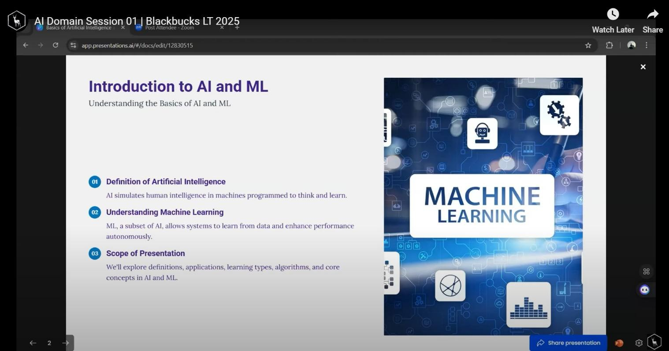

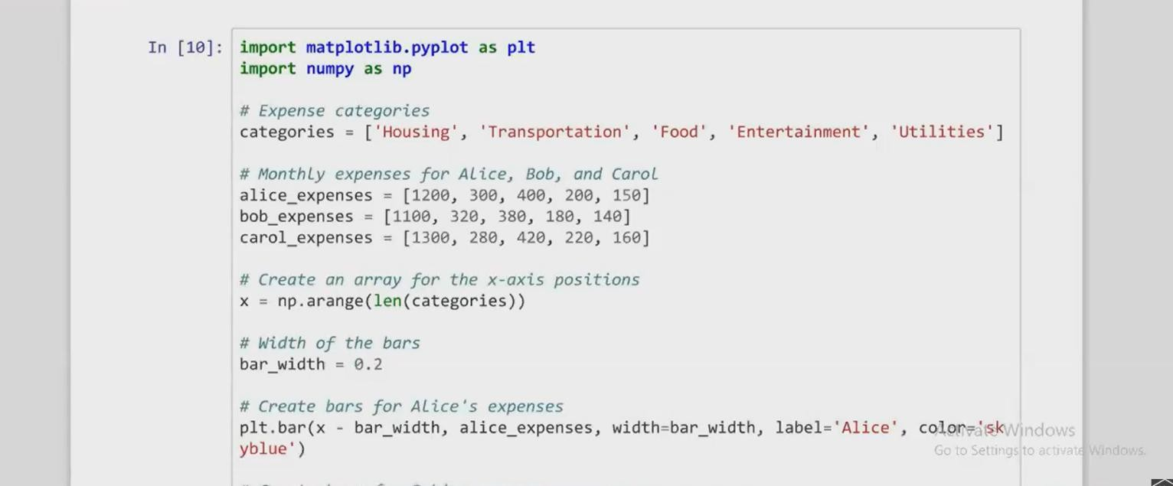

Fig 2: Data Visualization

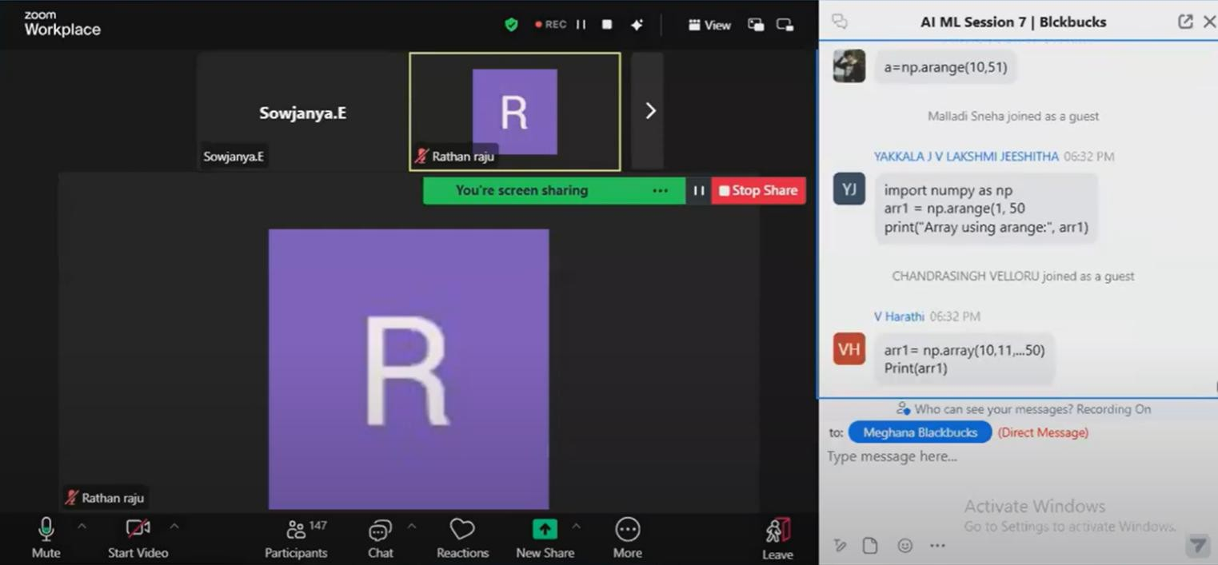

Fig 3: Session when Num Py is discussed

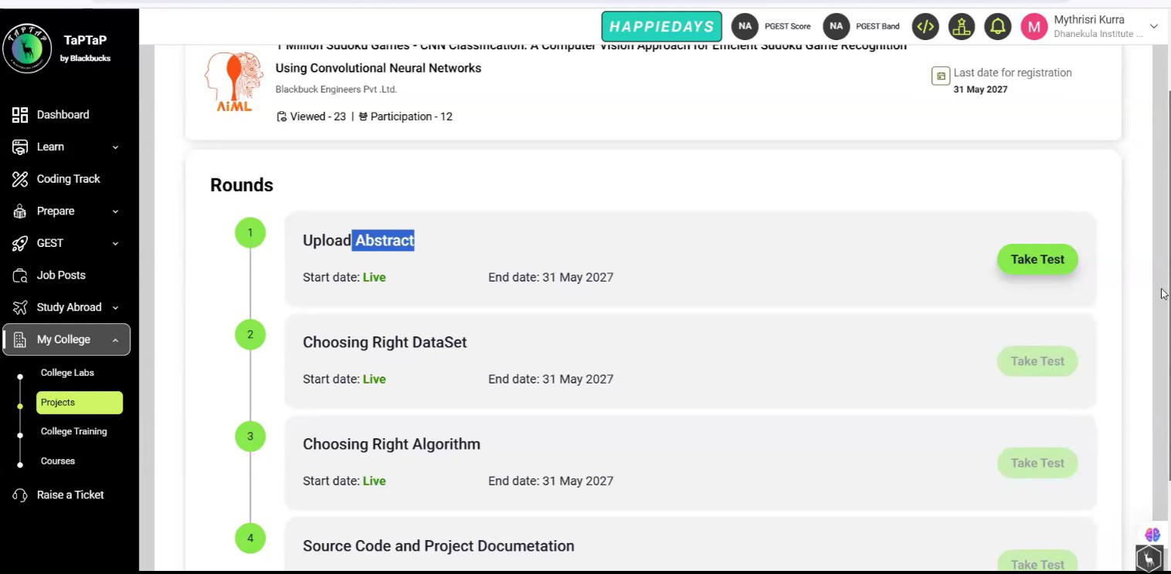

Fig 4: Project Session for how to submit the project

**Session Links:**

<https://www.youtube.com/watch?v=aHPyETcHFCo&t=1s>

[https://www.youtube.com/watch?v=Kyv1eNCIk7Y&t=7s](https://www.youtube.com/watch?v=Kyv1eNCIk7Y&t=7s%20)

[https://www.youtube.com/watch?v=QCrUI8fl7mY&t=8s](https://www.youtube.com/watch?v=QCrUI8fl7mY&t=8s%20)

[https://www.youtube.com/watch?v=wlCVD03WFak&t=2s](https://www.youtube.com/watch?v=wlCVD03WFak&t=2s%20)

<https://www.youtube.com/watch?v=POk5qurVtEw>

<https://www.youtube.com/watch?v=Dboz2zIXGkk>

<https://www.youtube.com/watch?v=iXhYlt4WzFE&t=1s>

**Grand Test Link:**

Grand Test 01: <https://taptap.blackbucks.me/hackathon/4049/>

Grand Test 02: <https://taptap.blackbucks.me/hackathon/4302/>